AI ASS 15.4
Name:B.Sanjana
H.T.NO:2303A52306
Batch:43

Task1:
Prompt
1.Develop a basic Flask application for a service management platform.
2.Create a root endpoint /status that returns a JSON response confirming the API is live.
3.Run the server locally.
4.Verify the response using a browser or API testing tool (e.g., curl, Postman).
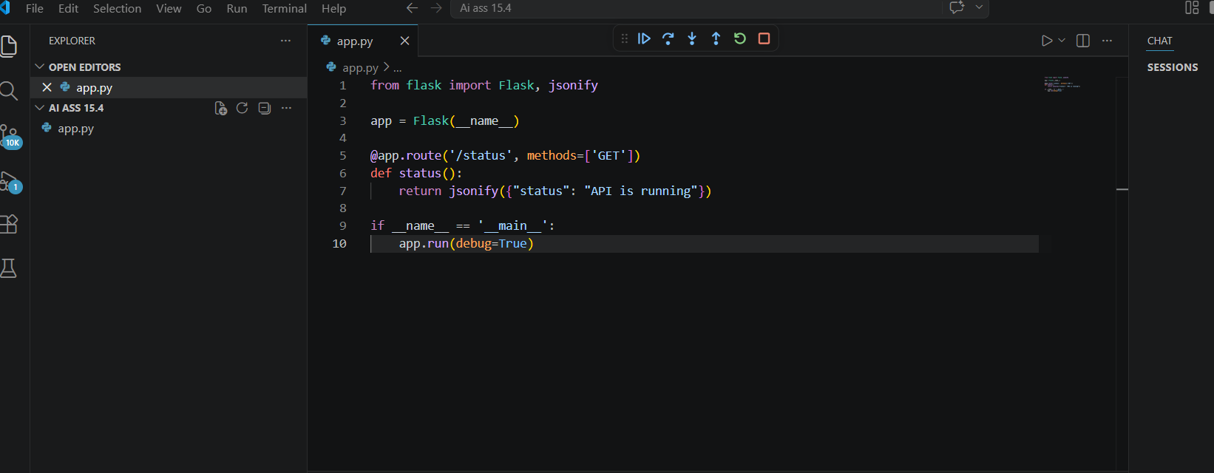
Output:
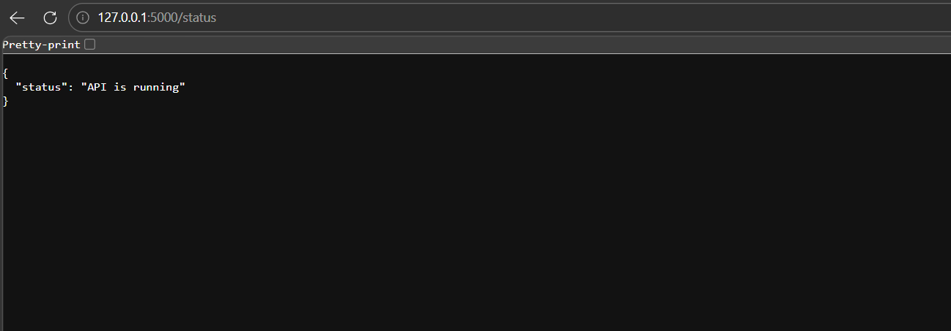
Observation
The Flask server started successfully on http://127.0.0.1:5000/ without any errors.
- Accessing the endpoint http://127.0.0.1:5000/status returned the expected JSON response:
{"status": "API is running"}
- The response was verified using both a browser and curl, and the output matched the expected result.
Task2:
Prompt:
Create a GET endpoint /requests to retrieve all service requests stored in memory.
- Create a POST endpoint /requests to add a new request with title and priority.
- Verify that GET initially returns an empty list.
- Use POST to add a request and confirm the response.
- Run GET again to ensure the added request appears in the list.

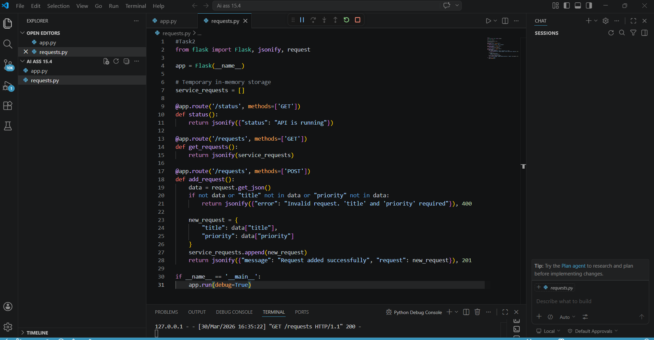

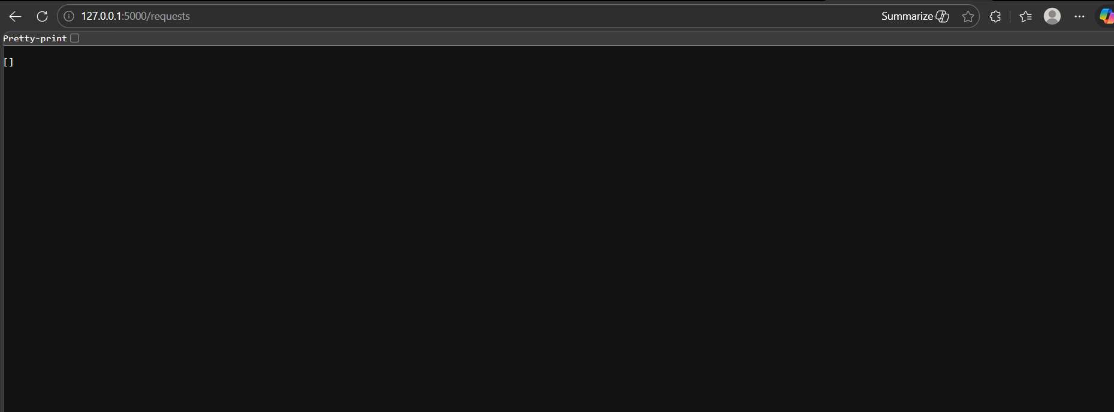
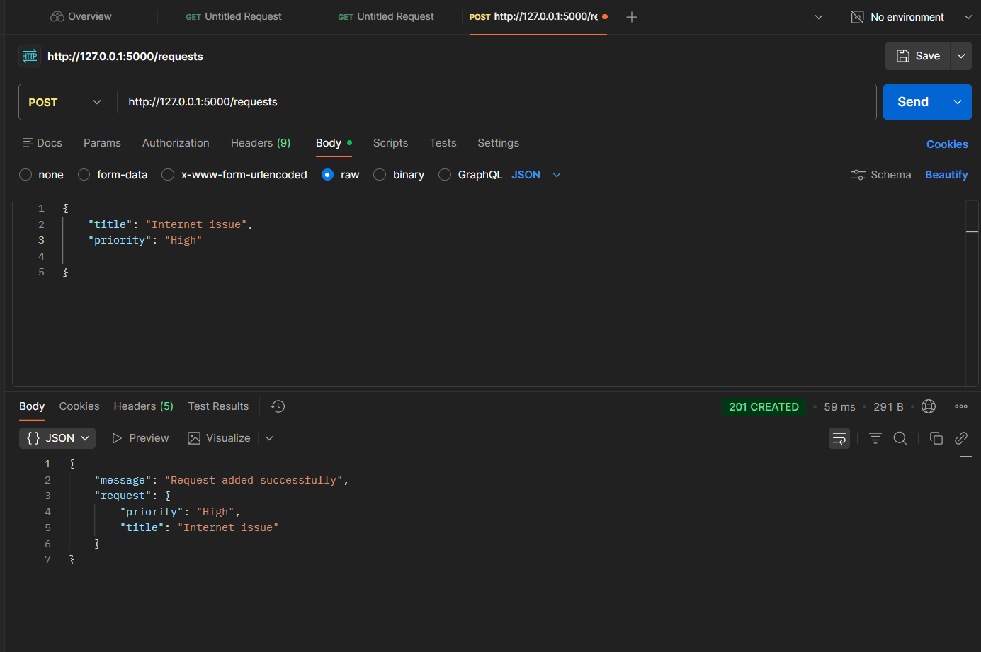
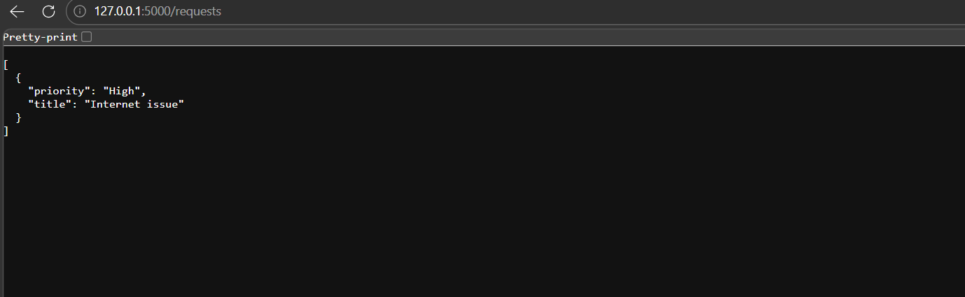
Observation:
- GET /requests initially returned an empty list [], confirming no requests were stored.
- POST /requests with {"title": "Internet issue", "priority": "High"} returned a success message along with the added request object.
- Subsequent GET /requests returned the list containing the newly added request, verifying that the POST and GET endpoints are working correctly.
Task3:
Prompt:
Create a PUT endpoint /requests/ to update a service request by its index.
- Ensure the request body contains both title and priority.
- Return the updated request object along with a success message.
- Handle invalid indexes gracefully by returning a clear error message with HTTP 404.
- Verify that subsequent GET requests reflect the updated data.
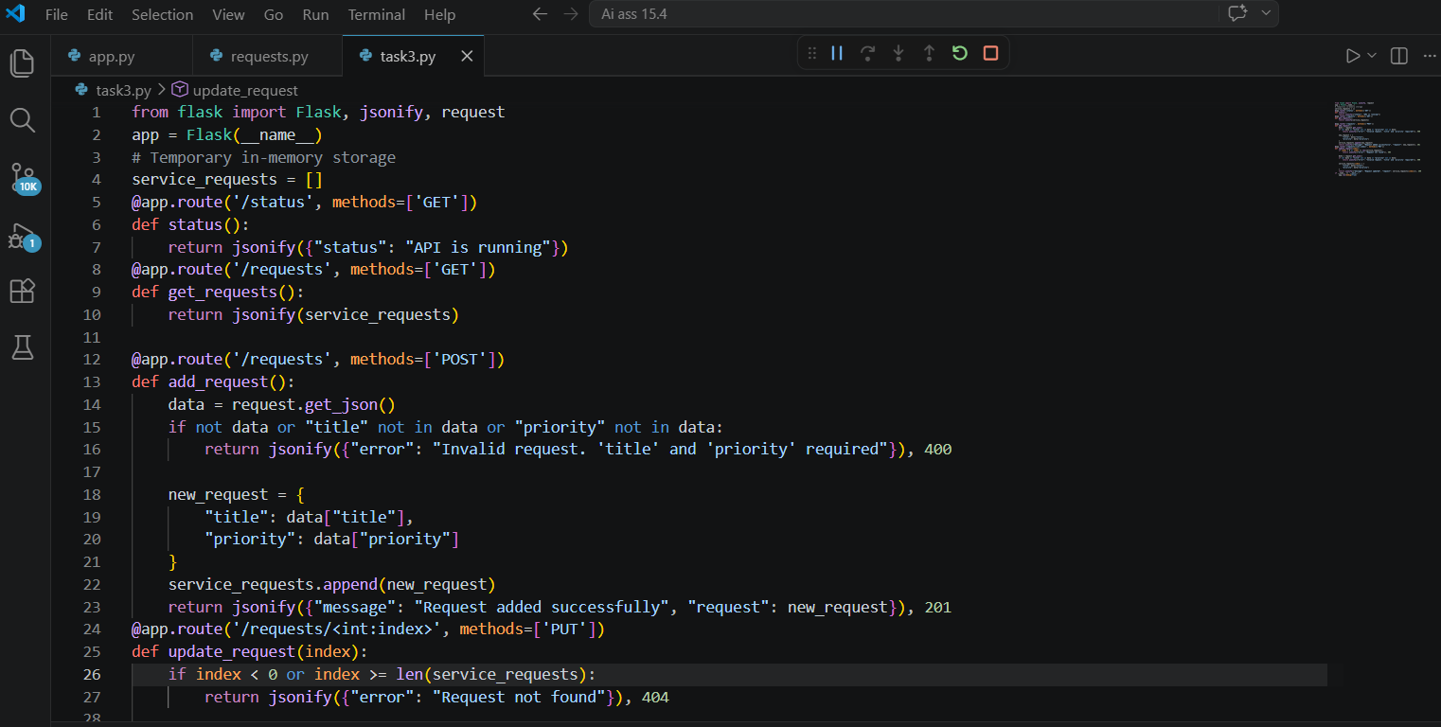

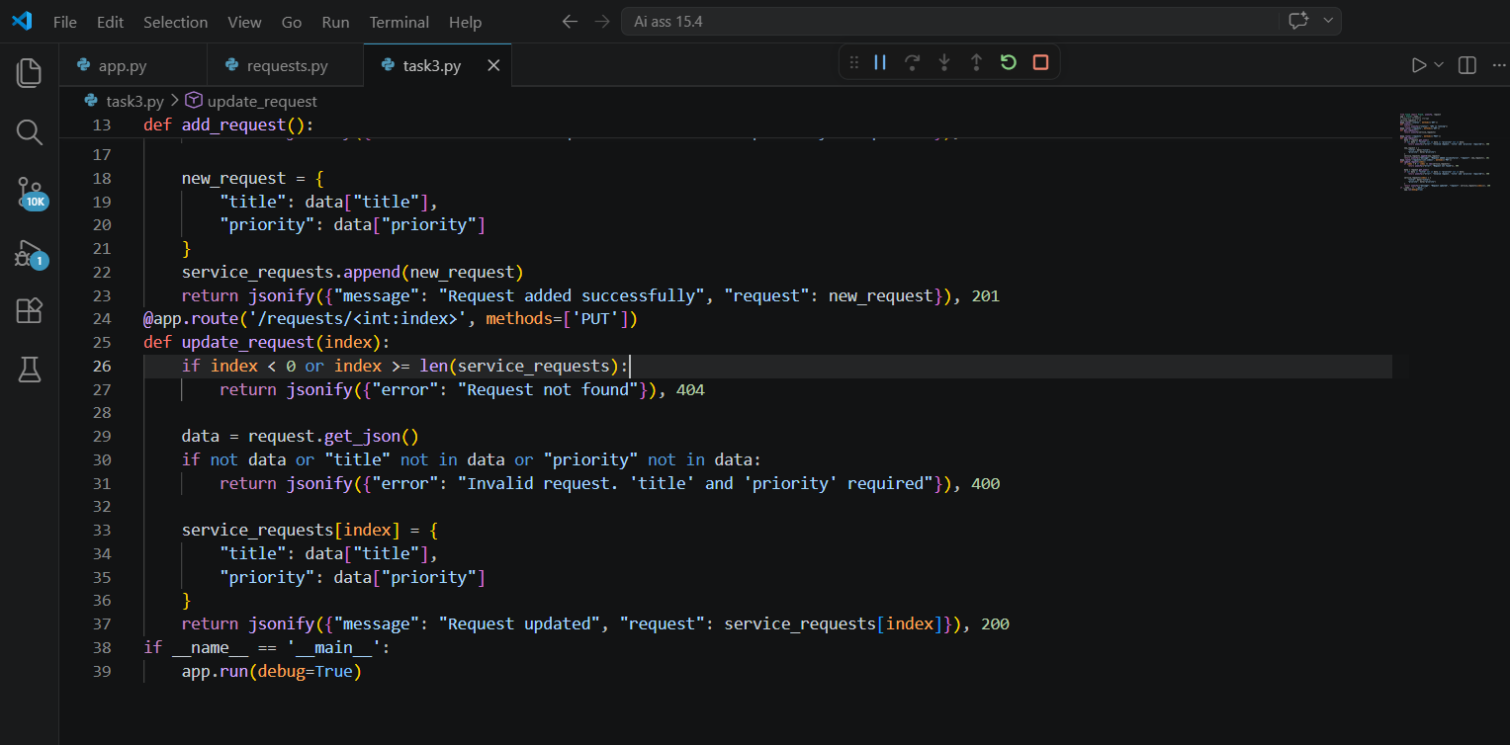
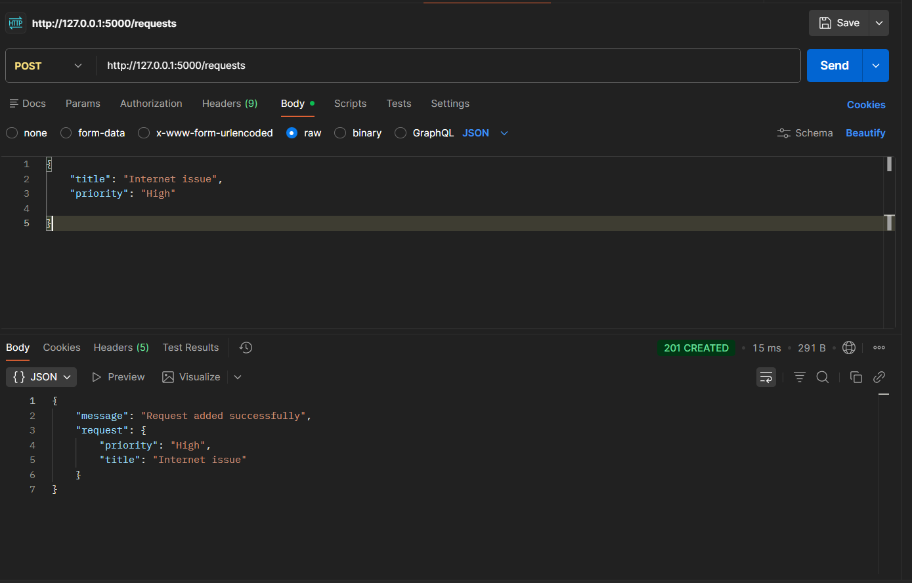
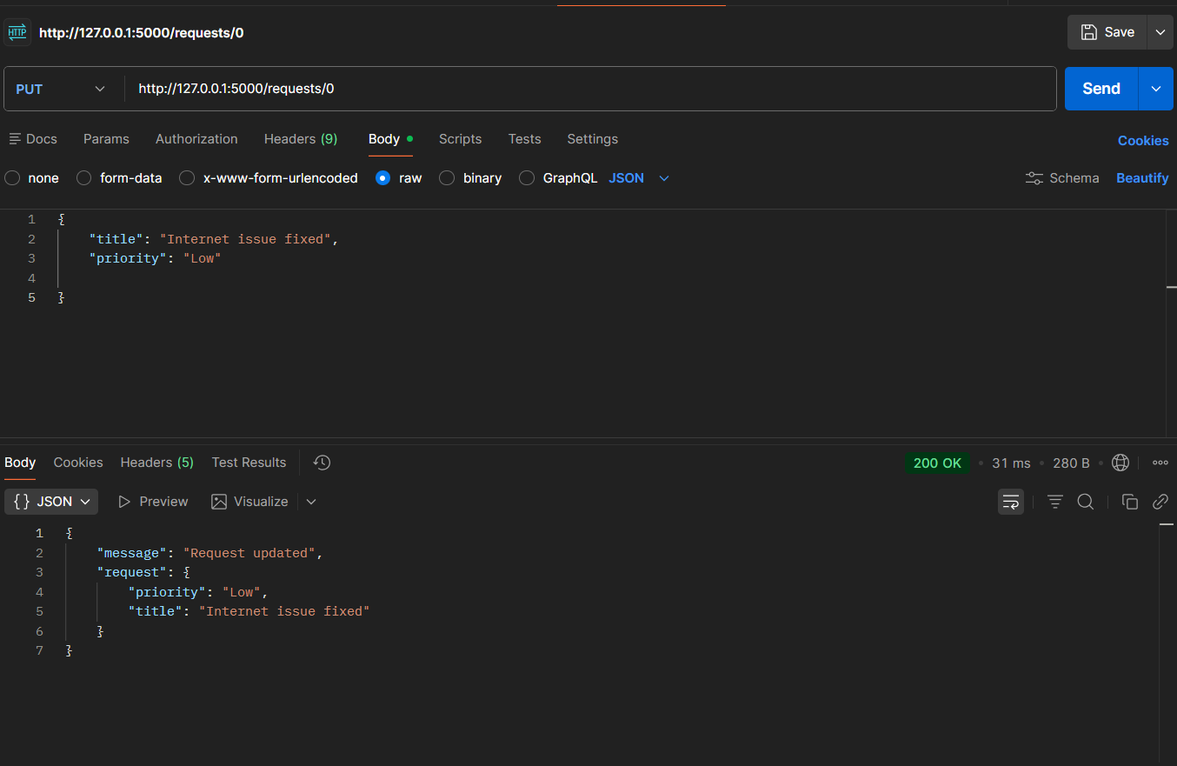
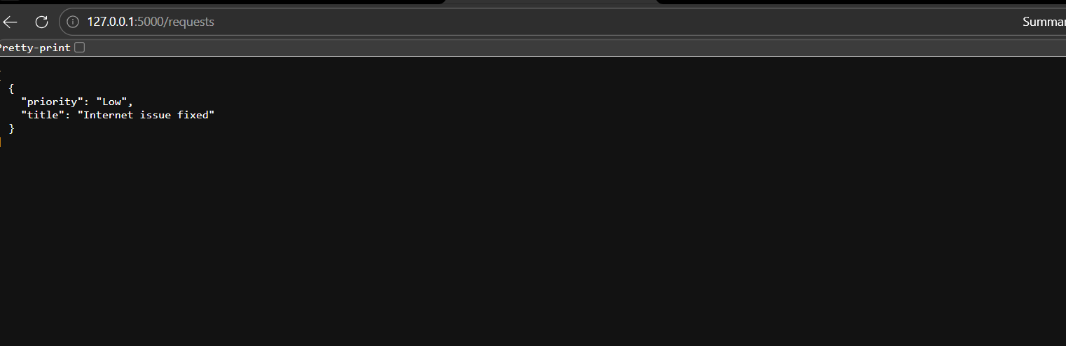
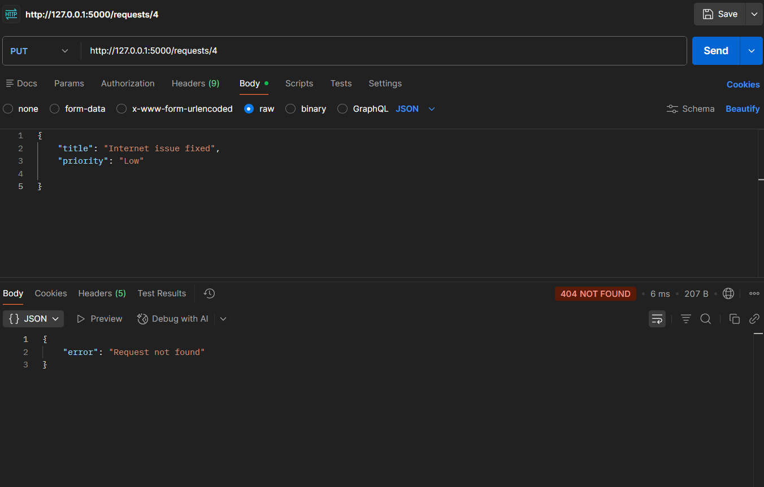
Observation:
- A valid PUT /requests/0 successfully updated the request’s priority and returned the modified object with the message:
{"message": "Request updated", "request": {...}}
- An invalid PUT /requests/5 returned a clear error response:
{"error": "Request not found"}
- with HTTP 404, confirming proper error handling.
- The updated request was correctly reflected in subsequent GET /requests calls, proving that the PUT endpoint works as intended and integrates seamlessly with the existing GET and POST endpoints.

Task4:
Prompt:
Create a DELETE endpoint /requests/ to remove a service request by its index.
- Ensure the deleted request details are returned in the response for confirmation.
- Handle invalid indexes gracefully by returning a clear error message with HTTP 404.
- Verify that subsequent GET requests confirm the removal of the deleted request.
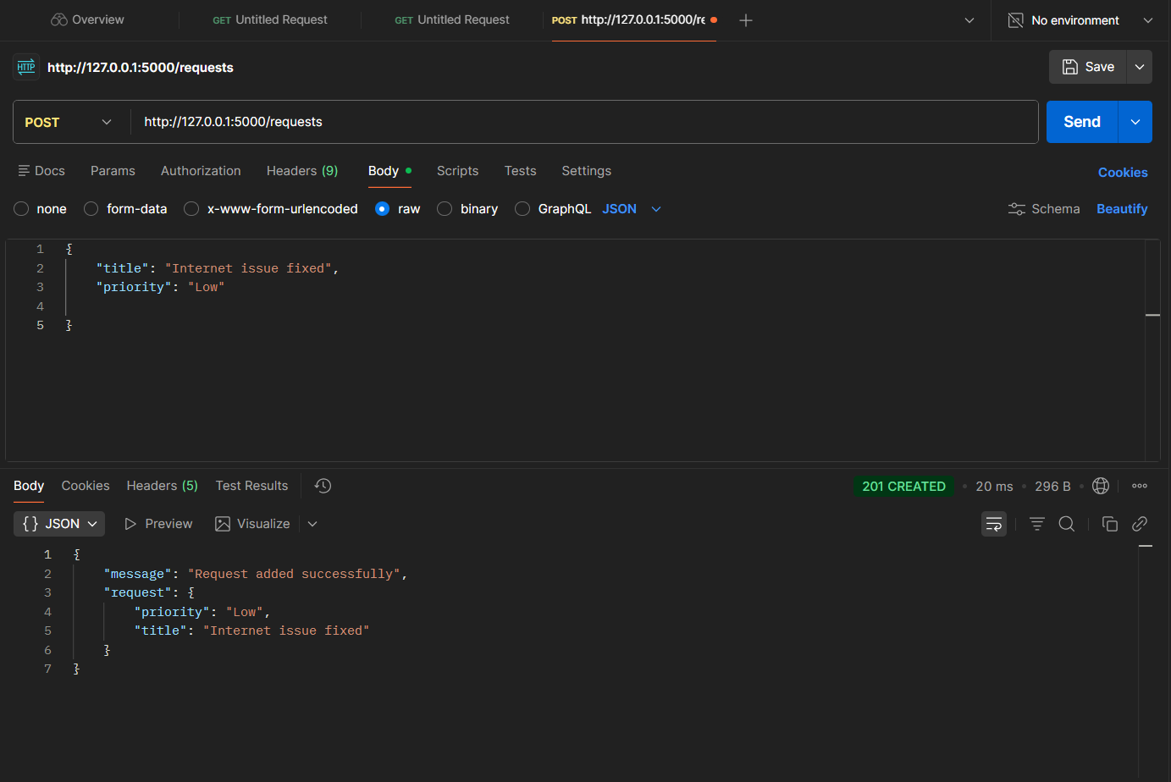
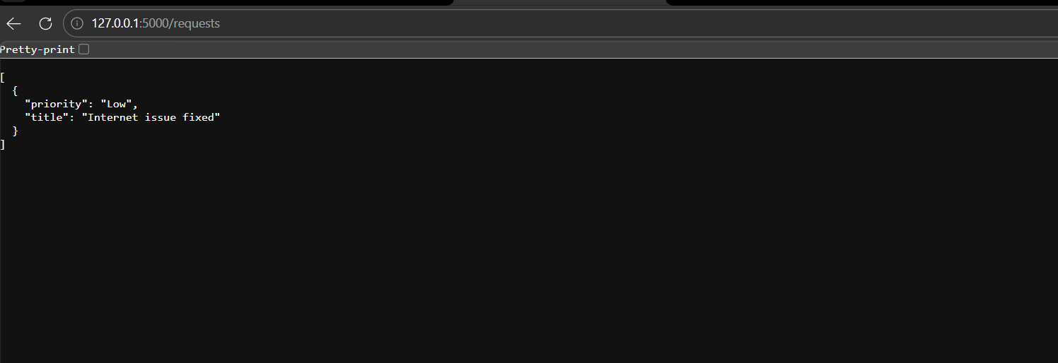

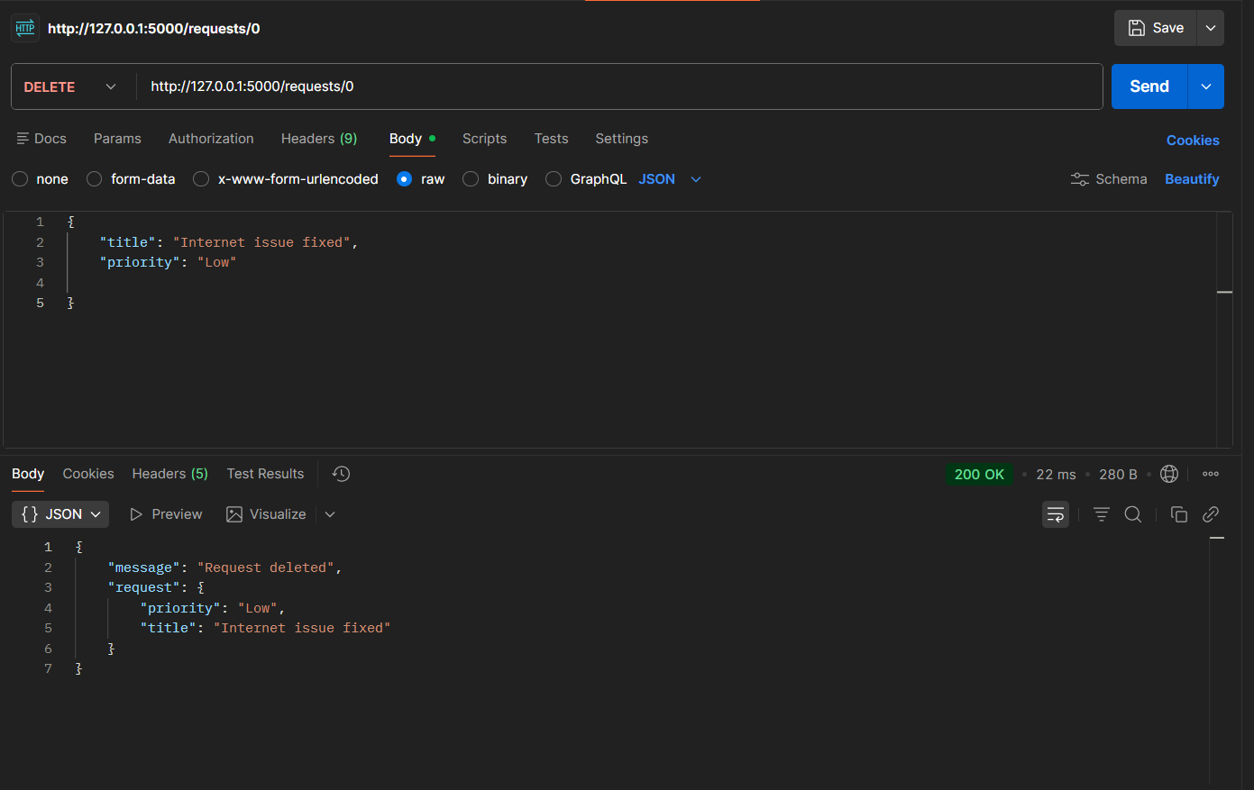
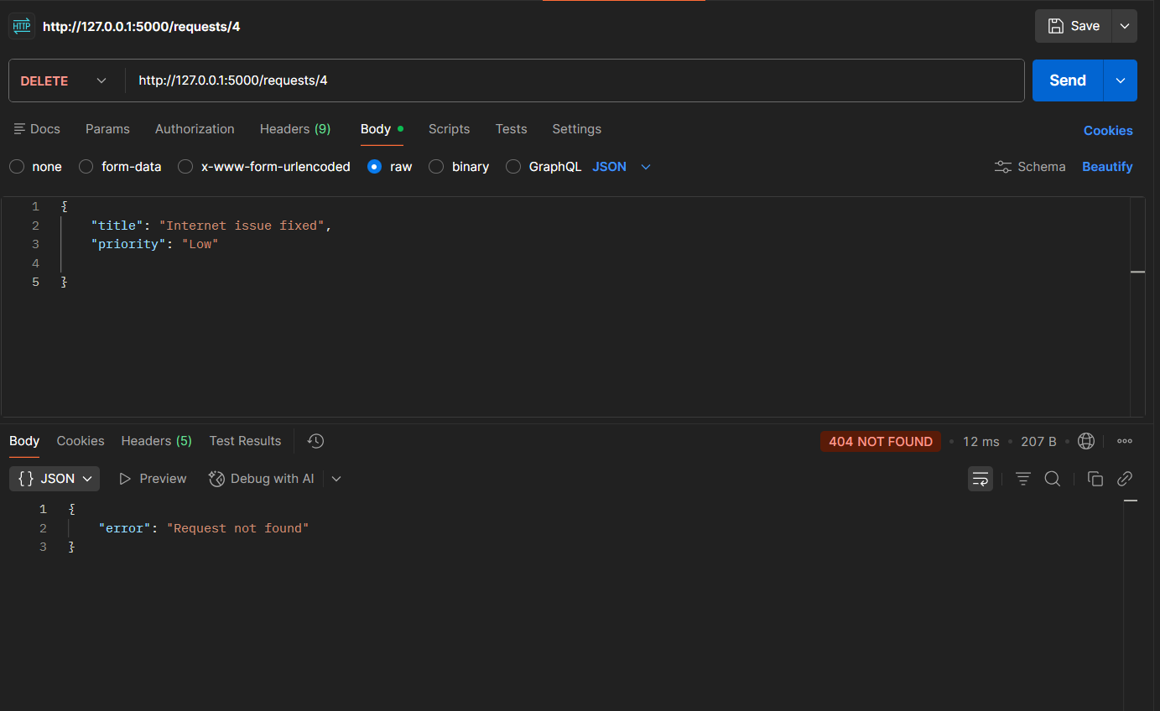
Observation
- A valid DELETE /requests/0 successfully removed the request and returned its details with a confirmation message:
{"message": "Request deleted", "request": {...}}
- An invalid DELETE /requests/5 returned a clear error message with HTTP 404, confirming safe error handling without crashing the server.
- Subsequent GET /requests calls showed the list without the deleted request, proving that the DELETE endpoint works correctly and integrates seamlessly with the existing CRUD operations.

Task5:
Prompt
Add meaningful docstrings to all endpoints describing their purpose, HTTP method, inputs, and outputs.
- Insert inline comments in the code to make logic and flow easy to follow.
- Clearly describe request methods, expected JSON body, and sample responses for each endpoint.
- Optionally integrate Swagger/Flask-RESTX to automatically generate interactive API documentation showing:
- Endpoint paths
- HTTP methods
- Sample request/response formats

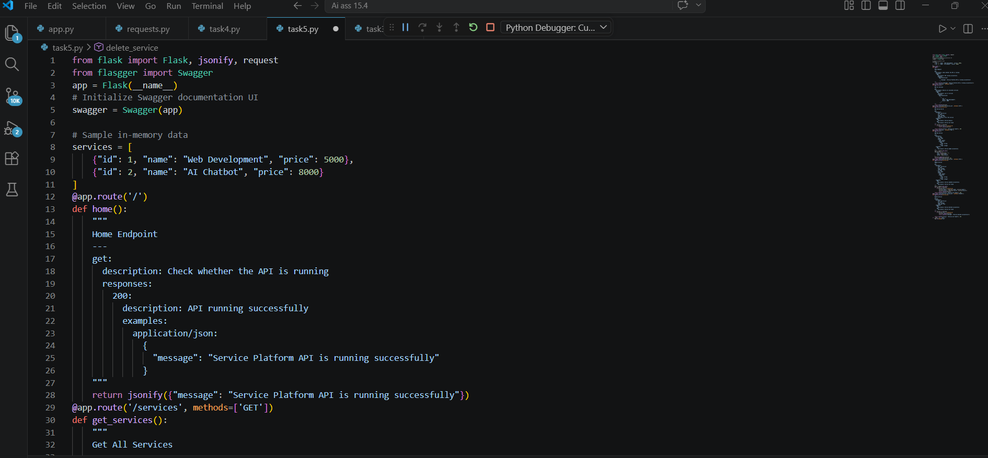
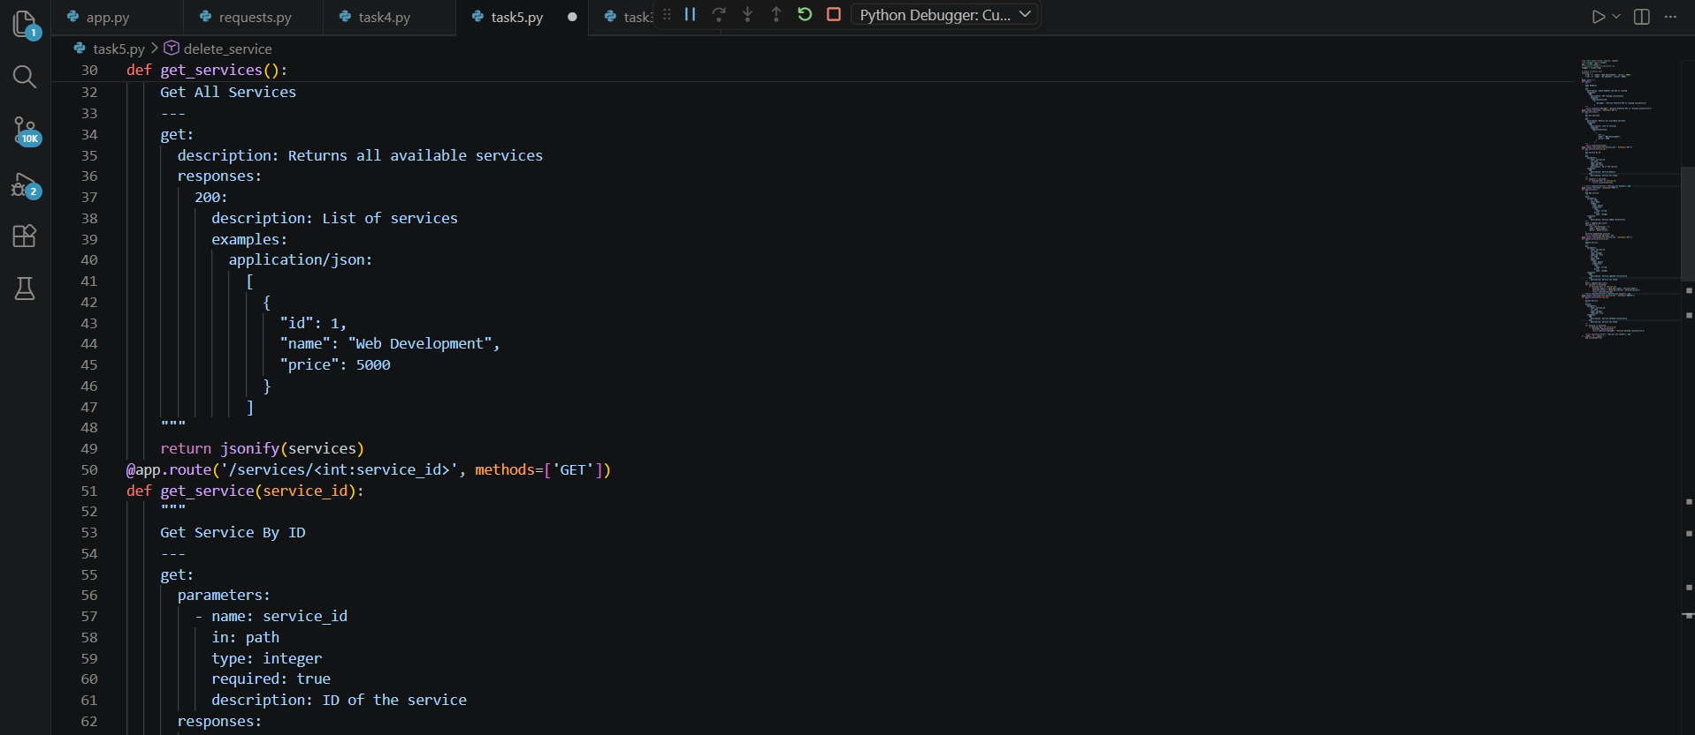
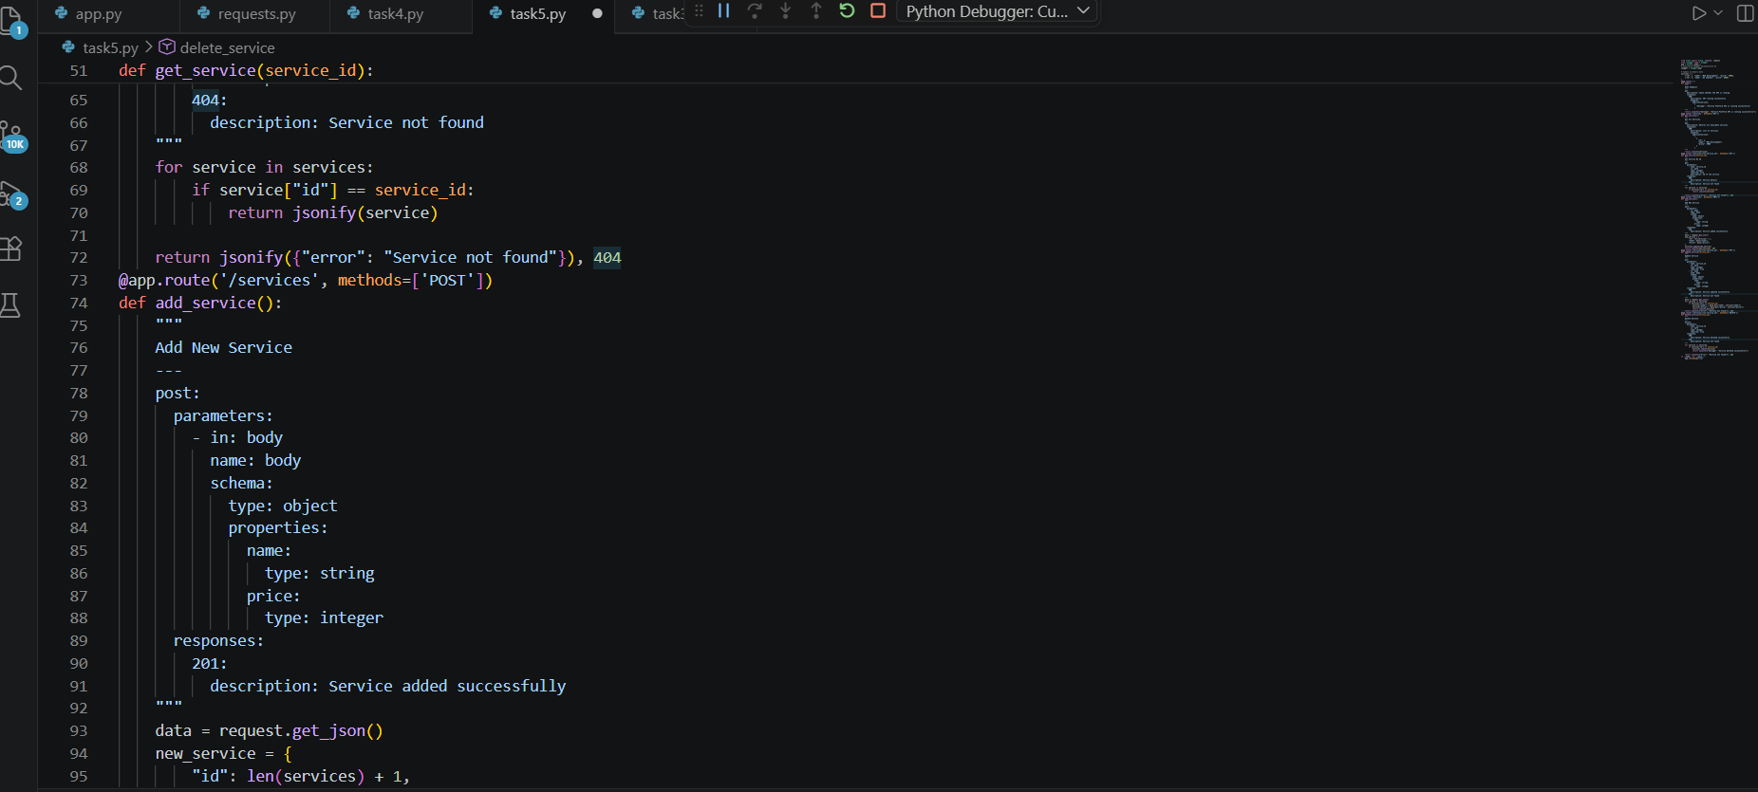
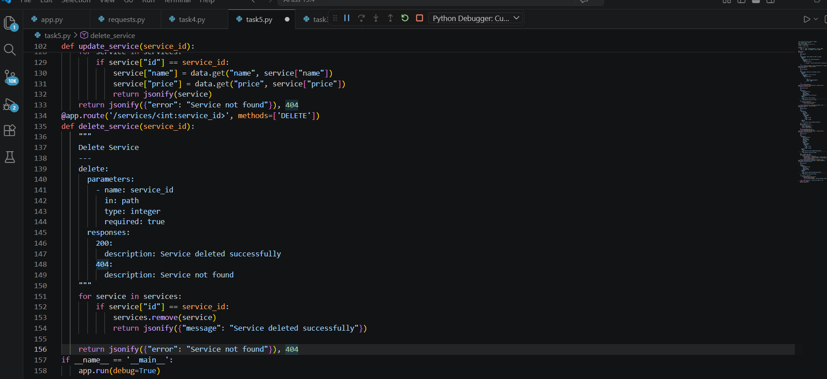
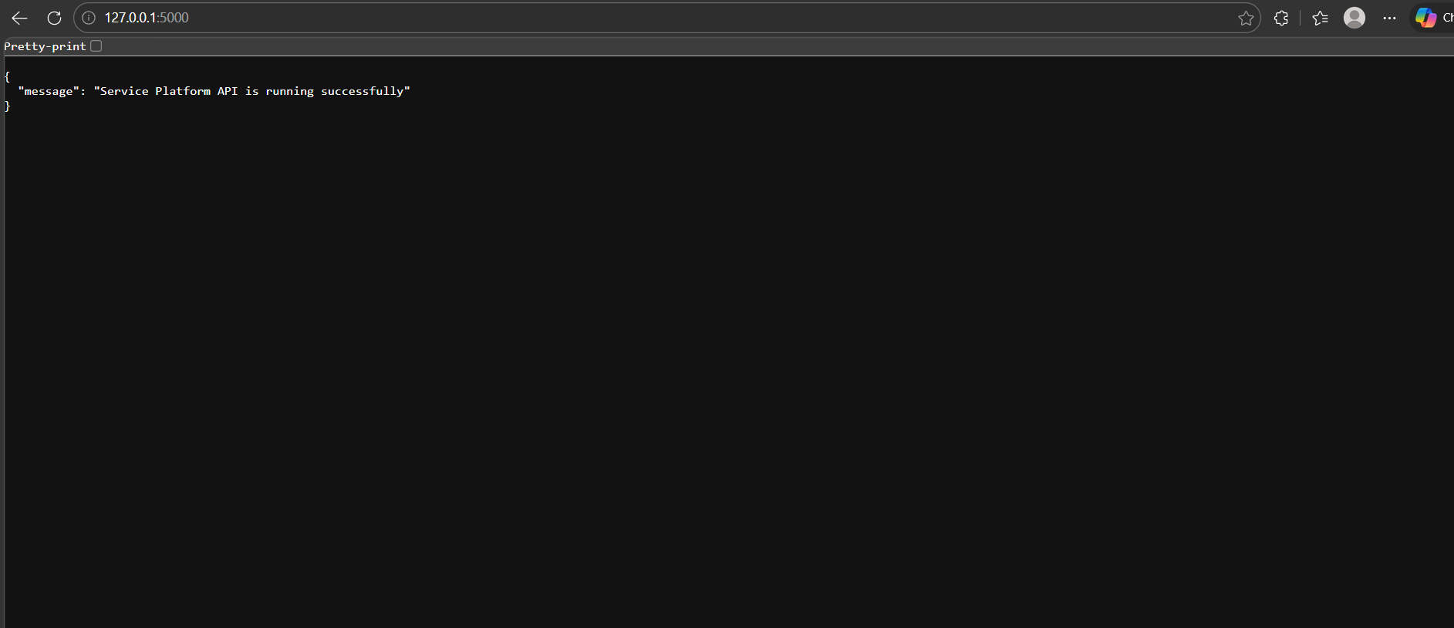
Observation:
Each endpoint now has well-structured docstrings that explain its purpose, request method, required inputs, and possible responses, making the API self-explanatory.
- Inline comments improve readability, allowing another developer to quickly understand the logic without reading the full code.
- The API is ready for optional integration with Swagger/Flask-RESTX, which would provide a browser-based documentation UI displaying endpoints, methods, and sample request/response formats for easier collaboration.

